**Module Descriptor**

**Section A**

* **Module Title**

Software Services

* **SITS Module Code**

UUI108010

* **SCQF Level**

8

* **SCQF Credit Points**

20

* **Module Leader, include staff ID and email address**

Nicola Hearnden NWH1NH

* **Module Team Members, include staff IDs and email addresses**
* **Faculty and Cognate Subject Group**

Faculty: Science, Technology and the Environment

CSG: Computing and IT

* **Exam Board and Exam Board Module Sub-group**

Computing & IT

* **Date of Module Start / Most Recent Revision**

September 2021 / March 2025

* **Semester**

SC

* **Minimum / Maximum Student Numbers**

Minimum numbers: 10

Maximum numbers: n/a

* **Pre-requisites**

n/a

* **Co-requisites**

n/a

* **Mode of Study**

Give estimate of proportions of mode of study but also highlight **main** mode of study.

Table 1: Proportions of mode of study

|  |  |  |
| --- | --- | --- |
| **Mode of study** | **Percentage** | **Hours** |
| Face to face |  |  |
| Video-conference (VC facilities on UHI campus or learning centre) | 15% | 30 hours |
| Video-conference (other video technologies accessed via Internet) |  |  |
| VLE (online, tutor-supported study) | 12.5% | 25 hours |
| Audio conference |  |  |
| Self-directed study | 35% | 70 hours |
| Other (please specify)  Practical sessions  **Team Activities** | **37.5%** | **75 hours** |
| **Total** | **100%** | **200 Hours** |

* **Assessment**

Table 2: Assessment

|  |  |  |  |  |  |  |
| --- | --- | --- | --- | --- | --- | --- |
| **Assessment number** | **Type** | **Details** | **Weighting** | **Component**  **Threshold Mark** | **Submission week** | **Learning Outcome(s) assessed** |
| **1** | Group Work | Portfolio of evidence, equivalent to 3000 - 3500 words in total. Evidence submitted in a variety of formats including essay, project, group work, practical, oral presentation, discussion board participation. | 50% | 40% | 14 | ALL |
| **2** | Report | 2000 words compare software deployment strategies and business impact | 30% | 40% | 9 (S1) | LO1, LO2, LO3, LO4,LO6 |
| **3** | Practical Code Demo | Demonstrate use of technical elements | 20% | 40% | 6 (S2) | LO1, LO3 LO5 |

* **Experiential Education**

Highlight all that apply

Work placement

Case studies

Simulations

Field trip

Laboratory work

Research project

Internship

Guest lecture

Clinical practice

Community engagement

Service learning

Job shadowing

Study abroad

Summer school

Volunteering

Co-operative education

Capstone course

Other

Other detail:

* **Specialist Learning Resources**

Students are expected to sign up to several online services that will facilitate their learning and team work. This includes but is not limited to:

· IBM Cloud

· Atlassian Jira

· Bitbucket.

These are available free to the student.

* **Additional Costs to Students**

Students are expected to have access to a computer that they have complete control over. The following table has the recommended minimum requirements for a system. This is slightly higher than the UHI minimum requirements found at <https://www.uhi.ac.uk/en/lis/buying-your-own-device>.

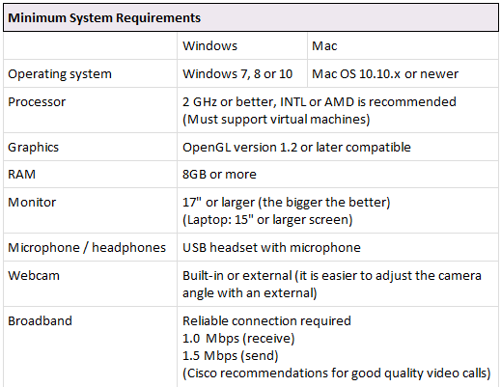

Students are expected to be willing to sign up to a range of industry standard tools located online. Students will not be required to pay for any software.

* **Employability / Graduate Attributes**

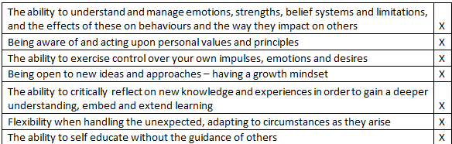  
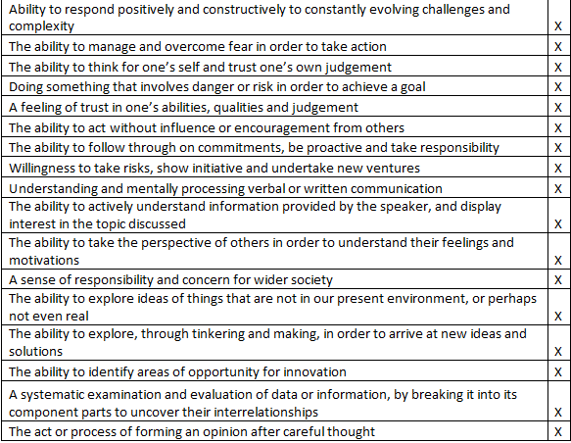

**Section B**

* **Module Summary**

This module aims to provide students with the skills to incorporate third party software into their software, using libraries, frameworks and APIs. Students will look at the wider problem of meeting customer needs and combatting threats to their business. This module will aim to enable students to be more creative, self-motivated and sustainable to achieve the goals in their Personal Development Plans.

* **Module Keywords**

Software development, frontend, mobile, browser, games

* **Module Learning Outcomes**

On successful completion of this module, students should be able to

|  |  |  |
| --- | --- | --- |
| **Number** | **Theme** | **Learning Outcome** |
| 1 | Agile | Explain agile project delivery and how it applies to rolling out a software project, ensuring accurate/timely deployment in a customer-friendly way, consistent with customer needs. |
| 2 | Business | Compare, from a client side, threat/risk/vulnerability and analyse typical threats, attacks, exploits. |
| 3 | Meta-skills** | Be creative, self-motivated, self-aware, reflecting on successes/failures in ways that build a positive attitude and self-reliance. |
| 4 | Security | Appraise and manage risk for threats/vulnerabilities to information systems on an ongoing basis. |
| 5 | Technical | Explain and apply concepts like loose coupling, separation of concerns, GoF, multi-tiered architectures. |
| 6 | Sustainability | Evaluate the environmental impact of third party software, including API's, cloud services and apply sustainable development practices. |

**Indicative Content**

**Skills that will be practiced and developed:**

· Compare methods of software deployment and the impact on the business

· Breakdown security threats from a business perspective

· Introducing multiple ways to incorporate existing code into new and existing applications

· Practice using third party services to enhance product features Syllabus Content

· Agile project management

· Release management

· Hotfixes and features

· Software versioning

· Secure programming for client environments

· Developing for multiple frontend platforms

· Using APIs to call third party services

· Using third party libraries to add functionality

· Accessibility and sustainability requirements

· Design pattern

* **Library Resources**

[Talis Library Resource List](https://uhi.rl.talis.com/index.html)